Harefield’s
(Bacon Hill & Woodland Park)
Role in D-Day

By

Stephen Read

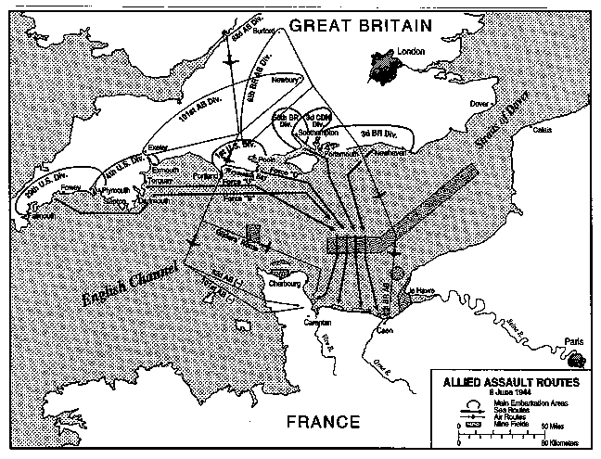

Preface

I have tried my best to gather up as much information as possible about Harefield’s World War II history, but due to the passage of time since the events sometimes evidence doesn’t remain and I have to give my best working theory.

I have referenced all quoted material at the bottom of the page. Some information given in this document which isn’t referenced may be inaccurate; I have tried my best to prove what I have written. Since I started looking at Harefield’s WW II history I have had to do several re-writes of this paper as the theories I had especially about the “U” shaped track have been proven to be wrong by eye witnesses who were there at the time. The best way to make sure you have the most updated facts and discoveries is to find the most recent version of this paper.

I hope you will find this to be interesting and informative reading and that this may inspire you to visit the site or do your own further research.

Stephen Read 26/4/2021

Introduction

Why did I become interested in Harefield’s role in D-Day? Well it was quite by chance. I was hoping to be able to manage an area of woodland by the modern Harefield Estate called Bacon Hill & Woodland Park. This area has been greatly neglected throughout the years accumulating a mass of dropped or dumped rubbish, overgrown pathways and a blocked up stream. Having cleared some sections of the stream and finding an old Marathon chocolate bar wrapper which hasn’t been sold in the UK since 1990 I knew that the woods needed care and management. I decided to look at old maps of the woods to see the layout of the woods and any pathways throughout the ages.
I found maps as far back as 1869–81 to modern maps. I noticed on older maps that the woods contained nothing but then for a period a “U” shaped track appeared in the woods only for it to disappear on more modern maps.

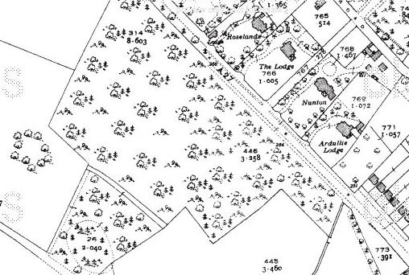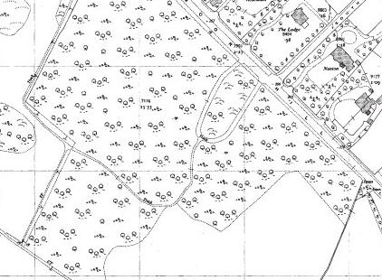
Map1933-40 Map1952-663

So why I though would a “Track” as it was labelled on the map appear and disappear? No other track on any of the maps seemed as wide or as odd shaped. The only other example of a “U” shaped road or track would be in front of a stately home where people would be driven round to an entrance and dropped off while the car would be chauffeur driven off around the rest of the “U” track. I knew that there had never been any house or building in this area that would have warranted such a track, the nearest building Harefield House was a good distance away and had burnt down in 1917 long before the “U” appeared.

Exploration

Having walked through the woods in the years that I lived in Harefield I had never noticed anything remarkable in that area just overgrown paths, litter and 5 old concrete posts.

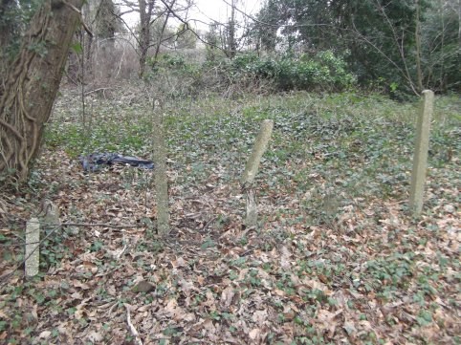
“The 5 Posts” 2 Posts still standing, 1 is bent and 2 stumps.

I decided to try to find any remnants of the “U” track for myself so went to the area shown on the map which is now behind Meon Court.

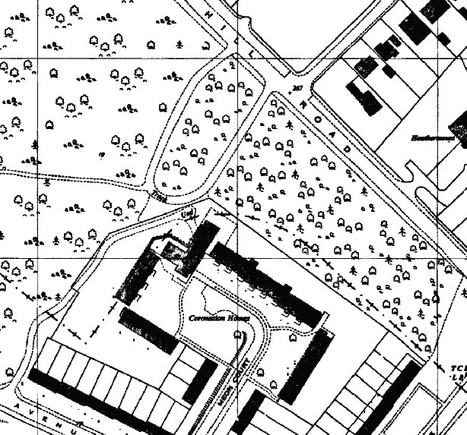
Map from 1965

I could not find a track or any connection with the A27 Moor Hill Road. I decide to knock on the door of a house nearby and while the gentleman could not remember a specific track he did tell me that the area was heavily used during World War II, indeed nearby there had been a workshop for waterproofing vehicles. Walking round the “U” area I found several brick and concrete structures.

Structures Found

These are pictures of some of the structures that I found in the area of the “U”, these show the structures as I found them.

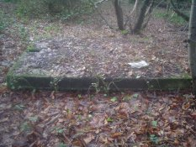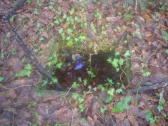
A big concrete slab A single “Hole”

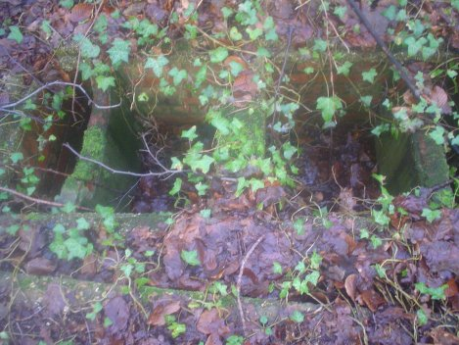
A large rectangular hole divided into 4 separate compartments

I did not know what these structures purpose had been and I was also amazed that I had walked by them before without noticing them. However considering that many of these structures are subterranean and are covered by years of growth it is not surprising that while walking on a path only feet away you do not notice them.

Evidence

I decided to ask West End Local History Society if they knew anything about the woods being used for military purposes, while they didn’t have any exact details they had heard a lot of anecdotal evidence from local residents. I decided to try the internet for any evidence and found a list of Army Camps in Hampshire. In this list was a reference to Harefield:

“Southampton, Harefield & Moorhill Park ? also Thornhill Park WWII D-Day Marshalling Area Camps. camp capacity 1,500 personnel & 210 vehicles at Harefield C1 2,500 personnel & 360 vehicles at Moorhill - C2”

This mentions that it was a Marshalling Area Camp for troops and vehicles, so I typed in Marshalling Areas online and found a page about the camps which said:

“The D-Day staging areas (or "marshalling areas") were known as "sausage camps" because they were indicated on some maps by sausage-shaped blobs.”

“the actual areas were to be as wooded as possible to prevent detection of the troop concentrations from the air”6

The quote that really stood out for me was that the area was to be as wooded as possible, I knew from looking at maps that this area of woodland had existed as far back as the late 19th Century. So by the 1940’s it would have been a good dense covering concealing any troop tents and structures that existed underneath the canopy.

The same website says:

“Once in a sausage, the routine was pretty much the same everywhere. All vehicles were equipped with the water, gasoline, rations, and other supplies that would be necessary upon landing. Vehicles were also water-proofed and equipped with snorkel tubes that extended well over the tops of the vehicles. All motor and drive-train vents were sealed with this water-proofing material as well as the entire electrical ignition systems. The water-proofing was needed in the event that disembarkation would be directly into the water.”

This confirms the story of the man I spoke to that waterproofing of vehicles was done in the area.

During my searches I also found a PDF called army_camps_history.pdf which is about

“Army camps: history and development, 1858-2000”

Part of this document says:

“In July British vehicle movement ceased through Area C, and some camps were reallocated as a consequence. Harefield was used for British personnel movement; the vehicle standings were to be used by US forces and reallocated to Moor Hill.”

This shows that Harefield was indeed used as a Marshalling Camp. A bit more research led me to a book called “Hampshire and D-Day by Martin Doughty“ which on page 171 shows this:

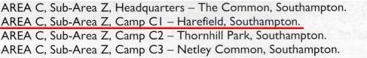

So Harefield was designated Camp C1, this proved that it had definitely been used during WWII but I had to tie this information to the site and the structures I found.
Final Proof

Final proof was found on the Archaeology Data Service website on a document which lists camps and their functions. Cell 497 lists "Harefield Camp (C1) D-Day marshalling camp" it gives an NGR (National Grid Reference) of SU467137. When this NGR is typed in you will find it points to the place on the map where I found remains of concrete structures.

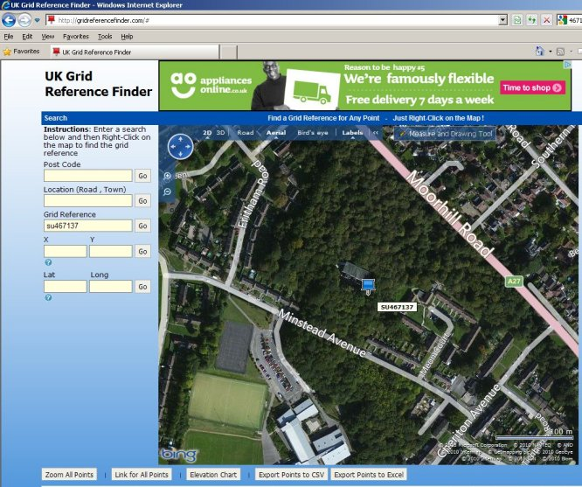
NGR location on modern map

When was the camp built?

To find out exactly when the camp construction began is difficult but referring to the excellent army_camps_history.pdf I managed to find this bit of information in the OVERLORD section:

“By October 28 the 1943 camp programme had been completed in Assembly Areas A and C, but no expansion work had been done. In Area B nothing had been done, and in Area D the 1943 programme was completed and the extensions were to be completed in 14 days.”

Remember that the Harefield marshalling camp was in Area C and was designated as C1. So according to the above quote by October the 28th 1943 the camp programme was complete in areas A and C.

When did the camp cease to be used?

“By May 2nd the build-up of the Overlord forces was well underway, though the camps were still far from fully occupied. After the Allies were successfully lodged in France the immense camping scheme could be run down. On June 19th it was ordered that all camps in Area A, with the exception of Roche Court, could be reduced from their expanded capacity to their original capacity. No reductions were to be made in Area C for the moment.”

“In July British vehicle movement ceased through Area C, and some camps were reallocated as a consequence. Harefield was used for British personnel movement; the vehicle standings were to be used by US forces and reallocated to Moor Hill”

“By December 1947 many of the wartime camps had been dismantled and the land derequisitioned.”

All you can conclude from these 3 passages is that by July 1944 the camp at Harefield was still in use, and by December 1947 it was probably dismantled.
Harefield’s Pompeii Uncovering the Past

All the remains at the site that I have found so far have been concrete, brick or old rusted metal and to the best of my current understanding that is all there is to find. The concrete structures which mainly consist of foundations for either buildings or vehicle standings lie just a couple of inches (5CM) below the soil and not a lot of vegetation has grown on it due to the fact that roots cannot penetrate through the concrete.

The other remains which all seem to have a water/plumbing function seem to consist of latrines and a single hole down which water pipes for the camp connect.

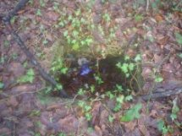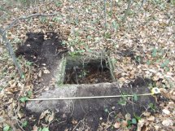
“One Hole” as I found it “One Hole” Scrapped off

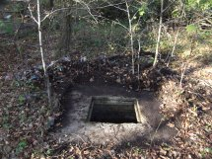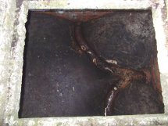
“One Hole” Top cleared “One Hole” Cleared you can now
see that it is a convergence
of 2 pipes into 1.

“One Hole” has a rim all the way around as if to support a removable cover as would be found with modern plumbing systems.

It is worth noting at this point exactly what a marshalling camp was. From the book Hampshire and D-Day by Martin Doughty:

“The marshalling areas consisted of a number of individual camps located in sites within a few miles of the ports. There were 18 camps in AREA A, with 22 camps in AREA C. Each of the camps had a similar lay out. The accommodation was arranged in blocks of 50 tents, sub-divided into villages of ten. Each tent held ten enlisted men, with separate accommodation for NCOs and officers. The camps were almost completely self-contained with their own dining areas, cook-houses, stores, latrines and entertainment areas, all linked together by paths and roadways. Surrounding the encampment, to regulate all personnel entering or leaving the camps, were barbed-wire security fences. Vehicle hard standings were prepared for lorries, armoured cars, tanks and equipment. Trenches were dug as protection against air attack and camouflage netting was strung among trees to help conceal the site.”

You will see by this description that the majority of the men will have stayed in tents while by the sounds of it NCOs and officers will have been in separate accommodation. I do not know if their dwellings were a more permanent structure or just tents like the rest but separated from the other men. Whatever the truth the majority of remains found will not have been for dwelling. The remains that I have found so far are either only slightly raised from the ground level at a few inches (10’s of CM) or are underground like “one hole”.

You will see in the next 2 pictures that I uncovered a large concrete base with a drainage pipe in one corner. I can only speculate that any structure that only had 1 drainage pipe was either a cook-house or wash room. Having spoken to local resident Alan Daw who has lived in West End since he was a child, he remembers solders’ knocking on his parents’ door to ask to use the bath as their facilities were very bad.

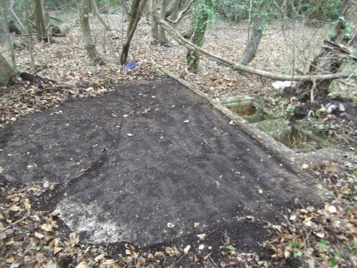
The concrete base near to the latrine

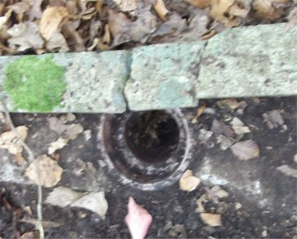
The drainage pipe in the concrete base

It is worth mentioning at this point that it was proposed in Britain that:

“Legislation to compel householders to give a hot bath to soldiers on demand, up to a limit to be specified according to facilities”

The proof that this site should have had many Latrines and a wash facility can be found in army_camps_history.pdf.

“The accommodation needed to be more than doubled. The camps were to be in blocks of 500 with one cookhouse to feed all ranks, and separate dining rooms for officers, warrant officers, NCOs and other ranks. It had been found that a scale of 16 ablutions per 1,000 men sufficed. Baths were to be in Nissen huts if these were available. The existing scale of latrines at 5% was inadequate owing to the spread of the camps, and it was suggested that the provision be increased to 7% where necessary.”

As the camp had “1,500 personnel & 210 vehicles at Harefield” there should have been at least 24 ablutions (washing places) which may have been in Nissen huts and based on latrines at 5% of camp maximum capacity of 1500 there should have been a minimum of 75 latrines!

This is an extract from My Memories of the Harefield Estate Transcript from a tape recording by Mr Chris Boulton 1997.

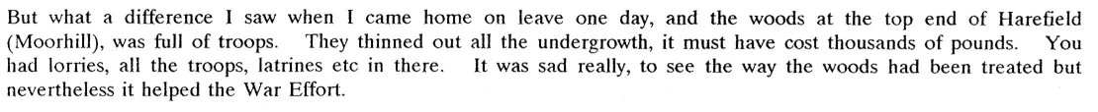

You can see he mentions that you had “lorries, all the troops, latrines etc in there.” So these latrines would have been very noticeable at the time the camp was in use. Not only do you have the what I believe to be the concrete latrines which are divided into 4 sections and are numerous near to the “U” track but I believe you have some more simple ones further away for the camp.
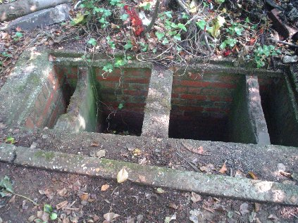
Concrete latrine by “U” Track

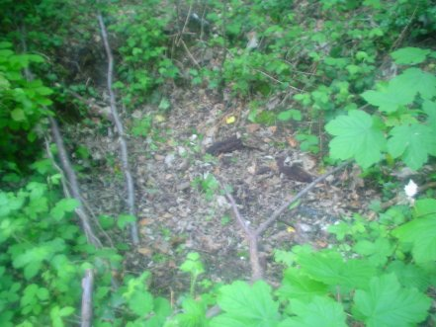
Simple Latrine dug into the ground
Dinning Hall?

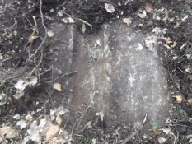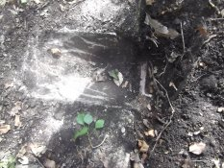
A gutter A slope to a drain

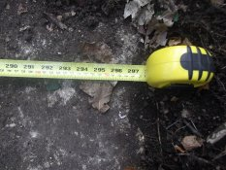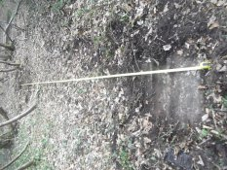
Measuring the concrete 297inches (754cm)

I found this large piece of concrete with a gutter on both sides and measured it. At 297inches (754cm) in old measurements it would be 24foot 9inches across, I have been unable so far to confirm the length but it is substantial. At first I thought this would be part of the “U” shape track but having looked at where the “U” is on the map I now know that is it something else. If the marshalling camp held 1500 Personal it would certainly need a large dining facility. I would imagine that this would be in a large Nissen hut, a description of one in the army_camps_history.pdf says: "A larger variant was developed, 60 feet by 20 feet, with a raised clerestory running the length of the building. Originally intended as a hospital hut, the design was also used for dining and recreation huts"
Below are some pictures of the partially uncovered concrete base that I believe supported a dinning room Nissen hut.

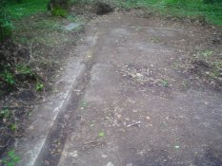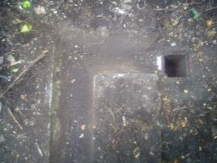
“Dinning Hall” and gutter “Dinning Hall” gutter and drain

What became of the “U” shape track?

The “U” shape track must have been used for large military vehicles and as the “dinning hall” base is made of concrete I originally assumed that the “U” track would have been made of concrete to sustain the weight of the vehicles. I thought this as all the remains I have found so far are concrete, and for a “track” to appear on maps for many years after WWII it must have been both permanent and substantial. The last time I can find the “U” track on a map is this map from 1978 - 1983

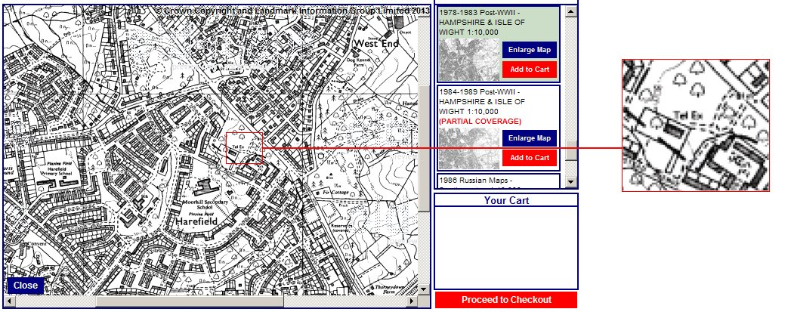
“U” track 1978 – 1983

I asked several people at West End Local History Society if they remembered the track and one day a man listening in the background said “Are you talking about that road in the woods?” after explaining what I was doing the research for he kindly agreed to give me this quote about the track which he remembers and not only that he drove on it!

“The concrete roadway was still in use partly but overgrown most of its way in the area in 1961-64. Ideal for dog walkers to park and walk the wood.”
Dennis. Local Resident

I do know that at least on one side of the “U” shape track there are 5 concrete posts which I presume have been added at a later stage to stop vehicles from using the track.
As local resident Dennis remembers it still being drivable in the early 1960’s I can assume that these posts were added after that period. There are no dropped kerbs on Moorhill road to show the location of the entrances so it looks as if it was destroyed at some point and any remnants of an entrance erased. I dug several test pits on a section I knew to be part of the “U” track both by the concrete posts and further into the woods.
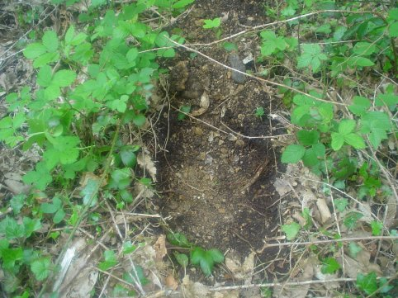
Test pit in “U” Track

I found that although it was hard to dig down into the ground there were no concrete or tarmac remains. The soil was very compact and full of large stones. I have recently talked to another local resident who lives in Southern Road who said “I am 99% sure that the track was made from gravel and not paved as it needed to be quickly made”

So why does this quote differ from that of Dennis who said “concrete roadway”? Well that may be due to the fact that when I was talking to him I was describing it as a road, or that memories fade with the passage of time and a gravel track can seem as compact as a concrete road when many years have passed. I should have realised early on that the description on the map is that of a “Track” not a road.

I have found an overhead aerial photo of the site as it was just after the war you can clearly see the “U” shape track

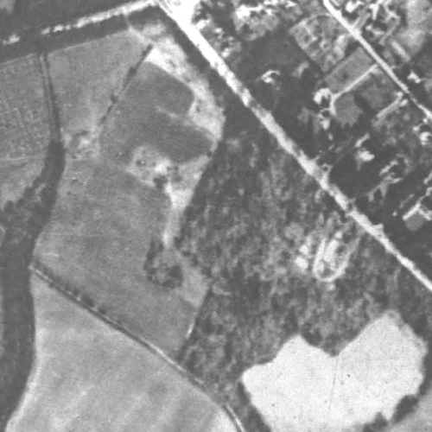
Aerial photo of the site taken shortly after the war

Not only is the “U” visible but so are other structures inside and outside the “U”. It seems as if this area has been cleared deliberately for the construction of the track and laying of concrete bases.

This is an extract from My Memories of the Harefield Estate Transcript from a tape recording by Mr Chris Boulton 1997.

You can see by this quote that the woods were thinned out and the picture clearly shows this.
One side of the “U” track I can confidently write about:
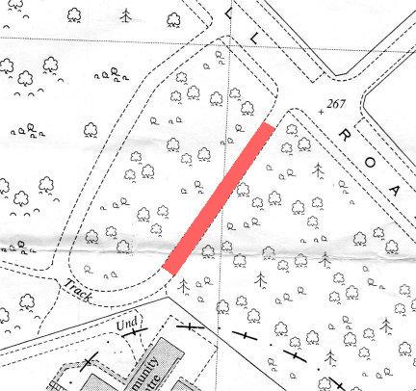
1961 Map showing the “U” Track

The above highlighted area can still be seen on the ground, the track surface is now covered by soil and growth but the compacted remains are still underneath. They are slightly raised from the ground level on either side; no substantial trees or bushes have been able to grow on the compacted stones. The next 2 pictures nicely illustrate how although gone from maps and from aerial pictures, when on the ground you can see where the track was.

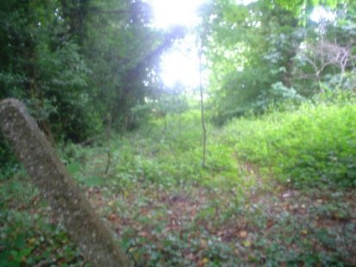
The “U” track looking from Moor Hill Rd towards Meon Court
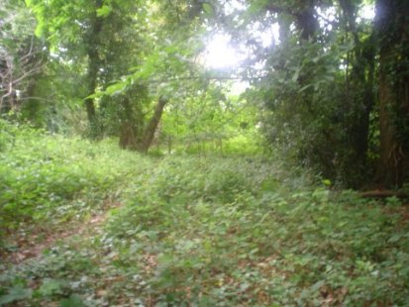
The “U” track looking towards Moor Hill Rd and “5 Posts”

“U” Track storm damage

The 2 previous pictures I am very happy to have taken as at the end of 2013 violent storms brought down several trees in the woods including several which now block this side of the “U” track. The 2 pictures below show how it currently looks, with “5 Posts” now covered in tree.

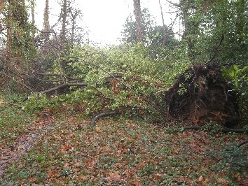
“U” Track obstructed by fallen trees

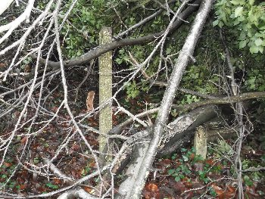
“5 Posts” now covered by fallen trees
Unknown structure (Coal Bunker?)

I found a 3 sided structure made of concrete with a flat smooth concrete base. While digging I found a lot of coal dust, then I found several lumps of coal

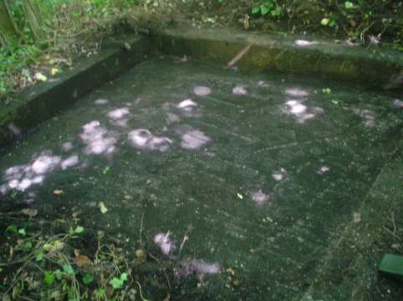
Coal Bunker?

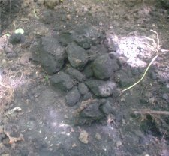
I can only assume that this structure was a coal bunker as it is 3 sided and contained the remains of coal (see picture) and coal dust. I do not know if coal could survive this long or why straight after the war people would not have taken it to use as basic supplies such as coal were I assume low. So until I have any other evidence I shall call this a “coal bunker”
Why the Concrete remains and nothing more?

You like me will probably be thinking at this point “Why are there just concrete remains as opposed to buildings?” Well there is a good reason for this, if this site used Nissen Huts you will see in army_camps_history.pdf that “Estimated life from date of erection, Nissen and plasterboard, 10 years” So even if Nissen Huts were left on the site they would be in a real state now if not completely destroyed. For a full and more compressive reason as to the lack of remains if you read the excellent army_camps_survival.pdf also from the archaeology data service it says:

“Additionally, remains of camps may survive as buried archaeology, even where they were of short duration or of temporary construction (e.g. tented camps). Hut bases may now be covered by turf as may be roads and paths. Often the superstructures of buildings were demolished, or salvaged for use elsewhere, leaving only their foundations that were too labour-consuming and expensive to remove. Sometimes floors and wall foundations were deliberately buried, or this has happened gradually as the result of a natural process. Many camps were positioned in woodland where their remains, out of general public view, have been speedily covered and largely forgotten. In addition to foundations, the buried archaeology may consist of pits, both for rubbish disposal and for sewage, and of fire trenches for defence. Within woodland, cleared and levelled areas between the trees where tents would have been erected can sometimes be discerned. Iron picket posts for fixing barbed wire may also be found.”

At the site in Harefield you can see only remains of the bases of structures or of underground plumbing type structures, so I believe that any buildings were destroyed or recycled and just the foundations left. Being in a woodland area there was no need to go to the time and trouble of digging up the thick and deeply buried remnants.

Artefacts found

The following artefacts were found in the area circled on the map below, I do not know if they are related in any way to the camp, I didn’t know of the camp when I dug them up as I thought they were a trip hazard being only partially buried.

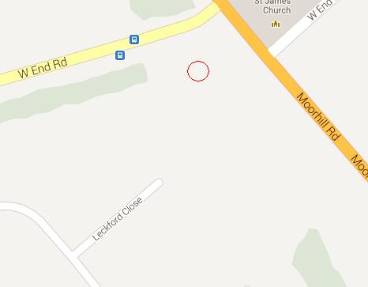
Location of metal finds

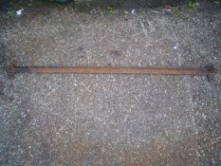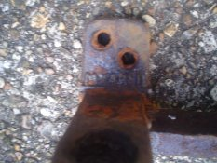
Long piece of metal “MYARED” stamped on the metal

This long piece of metal was slightly sticking out from the ground when I found it. It has 4 holes at the bottom on each end as if it should be bolted to the ground. The word “MYARED” stamped on the metal is a mystery to me. I have no clue what its purpose was.
The following pictures are of a piece of metal found very nearby to the last one, it was just sticking out of the ground exactly like the last item so of a similar age I assume. This piece of metal is actually several individual pieces all held together. One end of this metal is rounded whereas the other has a hinge as if this was for a gate to open. Once again it’s exact use and purpose is unknown.

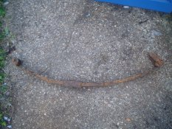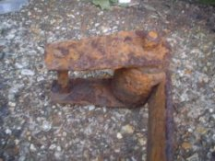
Bent pieces of metal Hinge

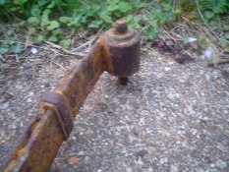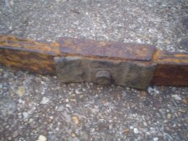
Rounded end Pieces of metal held together

Buckets

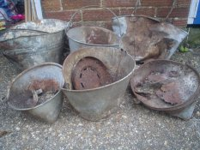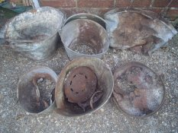
6 buckets side view 6 buckets top view

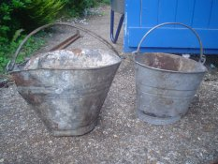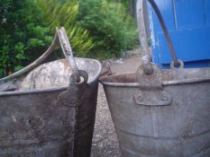
Side view of buckets Bucket handles well preserved

These 6 buckets are all of the same design and are in varying states of preservation, they were all found in the immediate vicinity of the remains of the camp and “U” track. I can imagine a local builder dumping rubble or garden waste but I can’t imagine them going into the woods to dump 6 identical buckets and scattering them around. I presume they were something to do with the camp although none of the buckets have any markings or dates stamped on them.

Communication Remains

I found several artefacts that relate to communication. I found a large and heavy metal object which I recognised as being used to anchor telegraph poles.

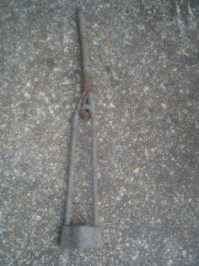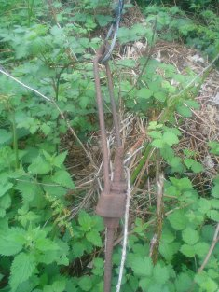
Telegraph pole anchor found near to camp remains. | Identical item in use on  Telegraph pole along Moor Hill Road today.

If you are wondering why the one found near to the camp is in better condition to the one still in use today on Moor Hill Road I can only conclude that having been under the cover of trees it may have been better protected from the elements and has not been near to car fumes unlike the one on Moor Hill Road.

The next two pictures show another find near the camp, and an identical item still in use in Chawton Close today.

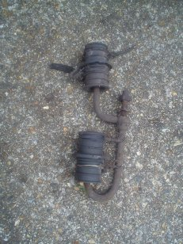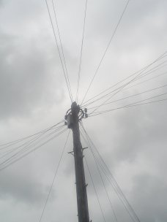
Found near camp | Identical item still in use in Chawton Close today
Map from 1978 - 1983

Note: In the area of the marshalling camp there is now a telephone exchange so maybe the communication remains may be rubbish from that building and not from WWII.
'Pigtail' Barbed Wire Anchor Post

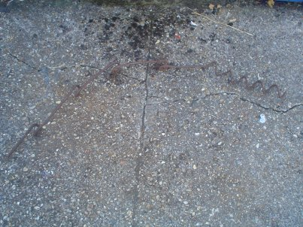
Barbed wire anchor post

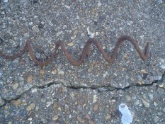  Screw | 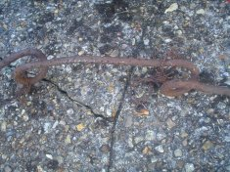  Wire in loop

There are several of these items near the marshalling camp they were for erecting barbed wire “The curly-bottomed fenceposts could be silently turned into the ground by inserting a bar through the 'eye' on top - thus avoiding the noise of trying to drive them in with mallets” and “apparently they were used in WW-I and WW-II”
Barbed Wire Posts

The next 4 pictures show 2 of the remaining barbed wire fence posts in the camp area. The first one is laid on the ground in dense tree covering, the other I cleared the vegetation off and is still standing upright.
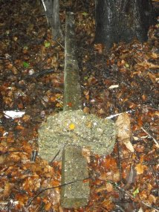  Fence post on ground | 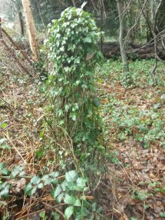  Covered upright post
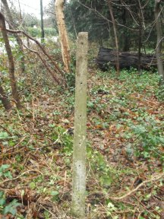  Cleared upright post | 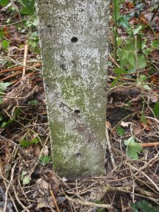  2 holes closer together at base
These posts have 8 holes, through which wire could pass, the post which is still standing upright in its original position is set back from the road by a few meters and I can well imagine a whole row of these post going all around the perimeter of the site. So what happened to all the other posts? Well I have a theory about that. In the woods I found a “mound” which seemed out of place and was overgrown by ivy so I set about test digging it. I found it contained a lot of concrete, bricks, tiles and nearby were the remains of yet another bucket! I found a lot of concrete footings for the barbed wire fence posts as can be seen on the post in the first of the 4 previous pictures “Fence post on ground”

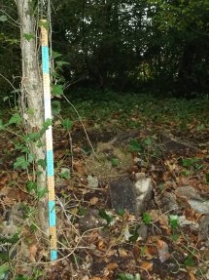  Mound | 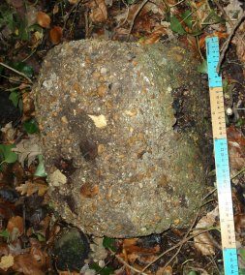  Post footing
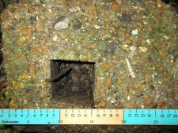  Another footing | 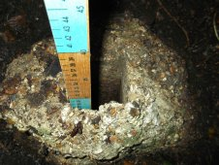  Footing 28cm deep
So this pile seems to be of dumped material from the Marshalling Camp after it was dismantled, useful material would have been salvaged and reused elsewhere I can imagine that the post would have been dug up and extracted from the concrete footings. The posts could have been used elsewhere as after all the still standing one is in great condition after 70+ years! The footings along with other unwanted remains were simply dumped in a pile maybe expecting to be cleared up at a later date which never happened. Why were some left? Who knows, maybe the one lying on the ground was waiting to have its footing removed and was simply forgotten about.

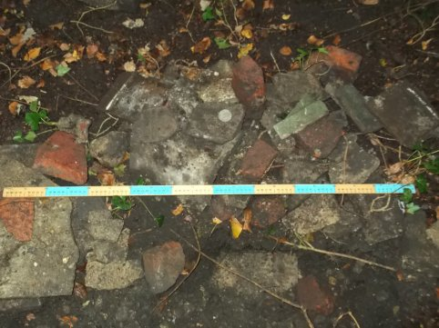
Mound rubble

You can see from the above picture some of the rubble from the mound when compared against a metre rule. How do I know Barbed Wire was used at all?
“In February 1944 Bushfield and Hursley were occupied by US troops. That month it was decided that the fences surrounding all camps in Marshalling Areas were to consist of triple Dannert wire.”
Cable, toy and bottles

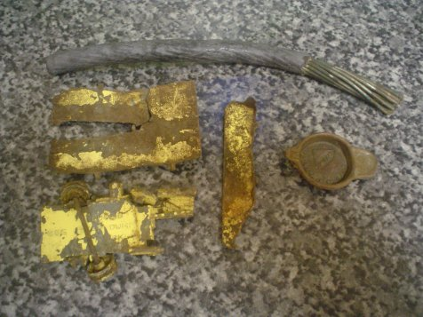
Piece of cable, toy and “VALOR MADE IN ENGLAND”

These items were found in various locations near to the marshalling camp.

  Jars and bottles |   Jars including st ivel

These finds may not all be from the time of the marshalling camp but I have no dating evidence for some, so I include them just in case they are related.
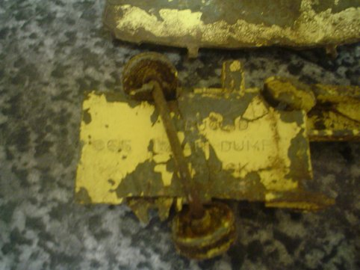
Toy truck

The toy truck says on it “EUCLID 965 REAR DUMP TRUCK”, this made it easy to date. I looked at the toymart website which says “Model Details for Dinky 965 Euclid Rear Dump Truck Color/Variation: Yellow, Produced from: 1955, Produced to: 1961.” So I know that this toy was last made in 1961 and considering the condition of the remains I think it has been at the marshalling camp for some time.

I find this to be one of the most interesting non WWII related artefacts that I have found. I like to think that some time in the 1960’s while the “U” track was still drivable and thus other remains more visible on the surface, a small child played with this toy on some of the concrete remains, perhaps re-enacting war games on what he knew to be a former marshalling camp only to forget it and not return.

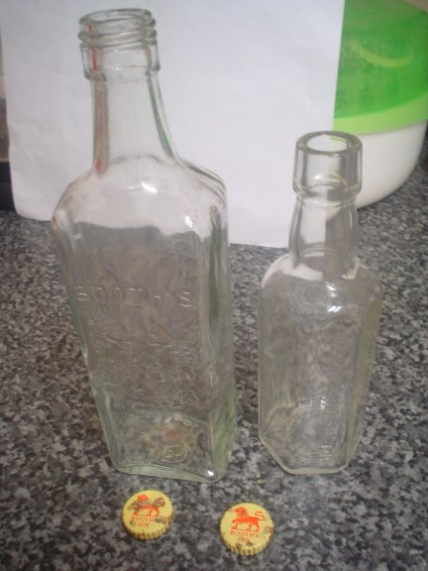
Booth’s Gin bottles and lids (unrelated to these bottles)

I have found these two Booth’s gin bottles in pristine condition I have been unable to date them. The 2 lids were not found near the bottles and do not fit them. I am not sure if this would have been drunk by troops or was drunk at a later time by someone loitering by the camp remains.
VALOR MADE IN ENGLAND

It was a while before I found out what the “VALOR MADE IN ENGLAND” item was. If you look at the next 2 pictures you will see this item and what it has come from.

 | 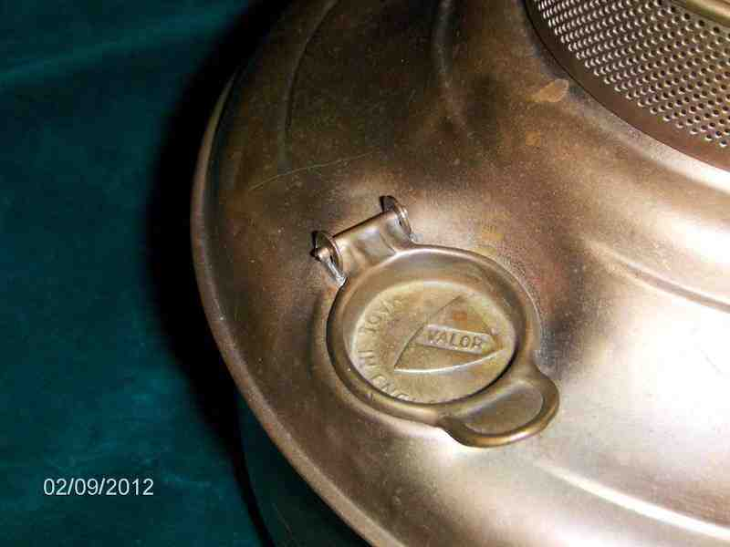

I found these pictures on a website which describes it as:

“A very rare Camping Tent Heater made by Valor of England. I believe the piece dates back to 1940-1950's. It appears to be in good condition & I think it is made of brass. There are some dents towards the bottom section of the heater. Patent Number 272 134. There is a dial to measure contents, 1/4, 1/2, 3/4, 1/1. The piece measures appx. 9" tall with diameter of appx. 9". A very rare camping collectible from Valor & a great addition to a collection!”32

Describing it as a “Camping Tent Heater” I can well imagine it being needed by troops as even camping in the summer months may get cold at night in the unpredictable English weather and don't forget that the camp was used beyond June 1944. I hope the date given of “1940-1950's” is accurate so far as the first part of the date. I can imagine this lid being snapped by a heavy handed soldier who threw it in anger into the darkness outside his tent.

Gun Cylinder

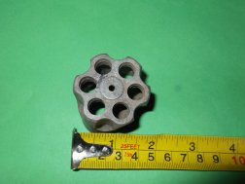  Gun Cylinder top view | 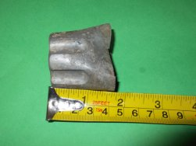  Gun Cylinder side view
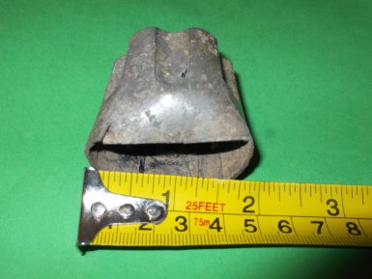
Gun Cylinder crumpled

This was found in the corner of the woodland by where Moorhill Road meets West End Road; I was not even looking for artefacts but was simply raking a path of dead leaves. This was very near to a fallen tree so I can only presume that it had been in the ground and only revealed when the tree fell and the roots ripped clumps of dirt from the ground. The Gun Cylinder has a crumpled area rendering it useless, I can imagine a scenario where a soldier accidentally damages his gun so throws the cylinder away and sources a replacement.
Making the camp safe

First I would like to point out that the remains in the woods were concealed in a dangerous way when I first found them, growth over 60+ years old had caused several deep holes to blend in with the landscape. Take a look at the next 3 photos.

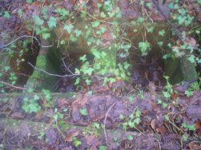  Latrine as I found it | 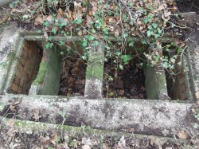  Latrine during cleaning

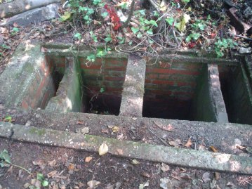
Latrine after cleaning

As you can see when I found the latrine it blended in with the surrounding landscape meaning that you could easily fall down into it. After cleaning it is now clearly visible and thus safer.
The next group of pictures shows “one hole”

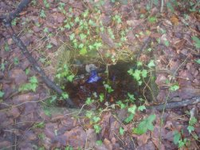  “One Hole” as I found it | 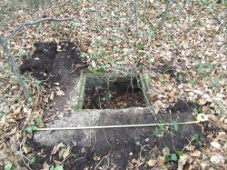  “One Hole” during cleaning
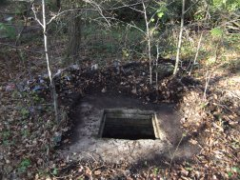  “One Hole” after | 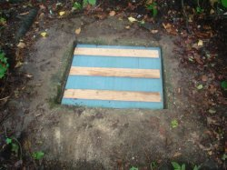  “One Hole” Safely covered

Once again you can clearly see how in the first picture “One Hole” was covered by creeping flora making it near invisible to anyone walking nearby. In the last picture you can see how I have used the rim of “One hole” to put a homemade cover over it, not only is this intended to make it safe if accidentally walked on but the blue cover clearly distinguishes it from the rest of the woodland.
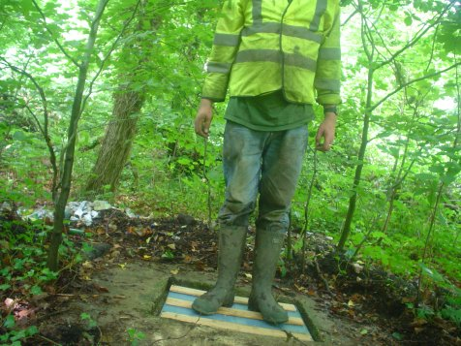
The author shows the strength of his homemade cover

To prove that this should hold a considerable weight you can see from the above picture that the author can easily be supported.

Update: On a recent visit to the woods I see that my cover had been smashed, I can only image a secure metal cover will solve this problem.
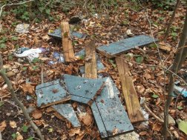
Smashed cover 2014
Dug Latrines?

The area of woodland I am now talking about is shown in the aerial views below, the first a photo which is contemporary with the camp and a modern view. The old aerial view shows little tree covering so this area probably wouldn't be used for hiding troops or equipment.
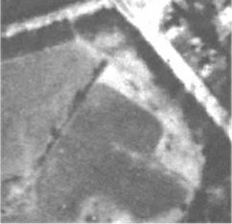  Old Aerial View, pre 1952 Harefield Estate but post 1944. | 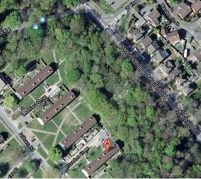  More modern view of the same site now with a dense tree covering

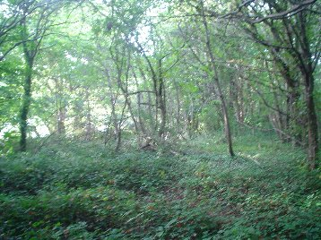
This is the current view of the trees from the ground level, here you can see all the trees are young and the area still seems very open and clear.
This area has at least 2 maybe more holes which have been dug to quite a depth, the holes are not circular which rules out a tree fall as the roots from fallen trees leave a round hole. I can only assume that these were dug to be used as latrines, I am unsure as to why here but this is my best theory for there existence.

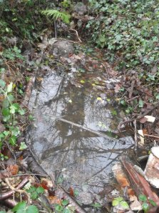  Dug "Latrine" still holding water after a heavy rainfall. | 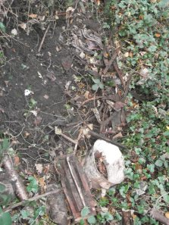  Dug "Latrine" dry and full of interesting artefacts.

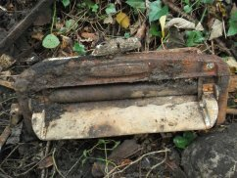  ACME Mangle in "Latrine", exact date unknown although believed to be 1930’s-1950’s | 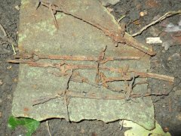  Barbed wire also in "Latrine", maybe "Latrine" was used as a rubbish dump after the war.

Outside the main site

Although I have talked about the main site there are some interesting remains outside the main area. Some are physical and others short lived buildings which are now long gone.

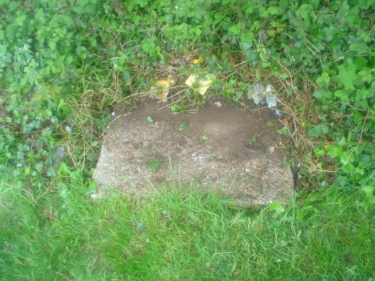
In-between the flats of Chawton & Leckford Close is an open area which has a grass slope at the end, at the top of this slope buried in the vegetation is this concrete cover with one metal ring and a hole where another metal ring would have been. The cover is butted against another slight rise in ground level and I do wonder if this cover shows the original 1940's ground level. While Harefield estate was made of natural sloping fields in the 1940's this was no good for the construction of the flats (Chawton & Leckford Close) and an area was dug and levelled. I believe the spoil from this excavation would have been dumped near by. This area after the war was devoid of trees thus making it a convenient choice (See black and white photo on page 43)
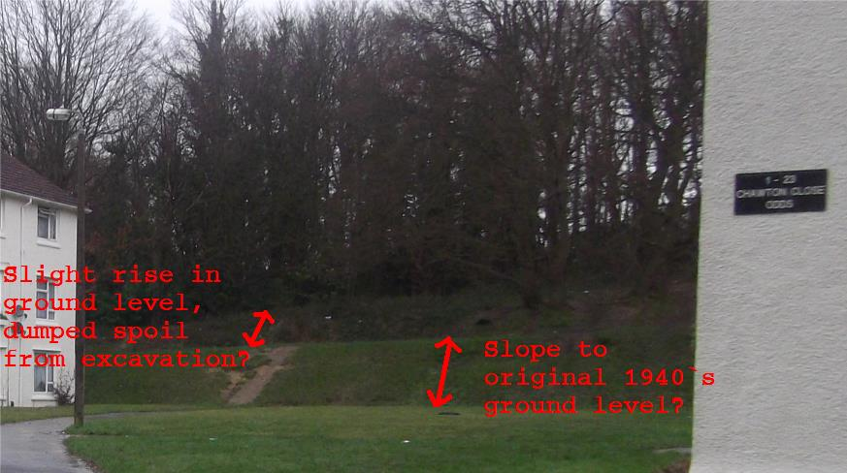
What makes me think this is a 1940's feature? I managed to get my hand with a camera down the side of this cover and took several pictures. Having reviewed the pictures it looks like this concrete cover hides a brick built structure with a similar water function to many of the dug brick structures by the main site. I can only assume that this one has been covered unlike the others due to it's close proximity to where people live. I am unsure of why this is so far away from the main site in an area which was completely clear of vegetation during the war and thus not used for hiding personnel (Page 43).

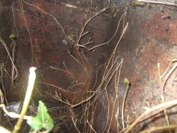  Inside view of brick structure near Chawton & Leckford Close | 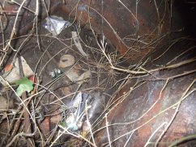  You can just make out a pipe entering this subterranean brick "Water structure"

The Wilderness Camp

Before World War 2 on the other side of West End road was "The Wilderness Estate", the Estate is described as ”The Wilderness, so named because of its original wild state, was once a large house standing in a country estate covering about 23 acres. Bounded by South Road (Chalk Hill), West End Road and Church Hill (A27), it sat on a high ridge, commanding fine views”

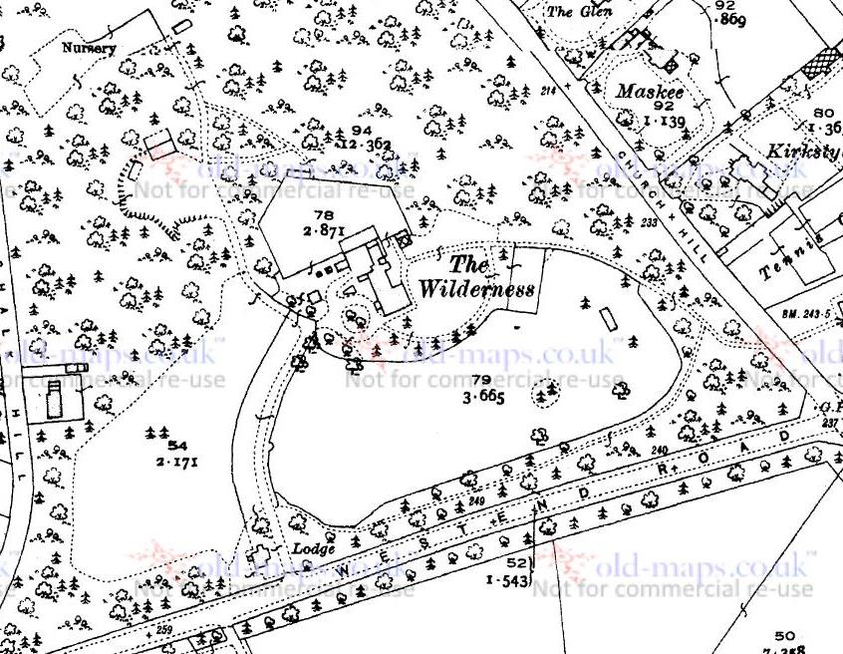
"The Wilderness Estate" Pre World War 2

During the war as with Harefield Estate the Wilderness Estate was used for the war effort :-
"During the wartime, the house and grounds were used for billeting American and British troops, building up to D-Day. It was later used by Land Girls working on West End farms."
What I find interesting about the fact that this area was used is that there is not really an acknowledgement of it's use on wartime maps.

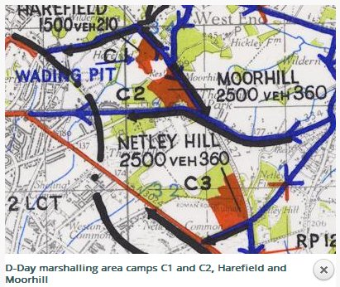
The above map shows Camp areas as solid red, so while Harefield is clearly shown there is no corresponding red patch in the Wilderness Estate which can be seen by the black text "1500veh210". Each camp would have been sealed when D-Day was approaching so it is not as if troops would be travelling from The Wilderness Camp to the Harefield camp and vice versa. The Wilderness would have been self contained just as Harefield would, yet it is not mentioned even though it must have had living accommodation, wash facilities, cooking facilities and dinning facilities at a minimum. After the War :-

"The 22 huts erected in the extensive grounds of The Wilderness were re-used for housing the many
homeless after the War had ended."

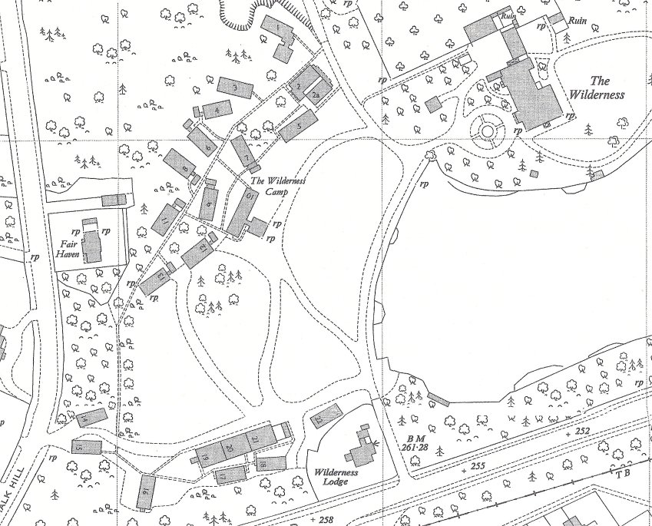
Post war map of "The Wilderness Camp" 1950-54

This map shows the layout of "The Wilderness Camp" post war, I think that the buildings which I presume are Nissen huts have been numbered as they were currently being used as living accommodation or had been and thus needed house numbers.

Mrs Riggs

Mrs Riggs was a lady who lived at the Wilderness Lodge from the 1940's until her death in 2017, I was lucky enough to speak to her on her doorstep in 2014 but didn't record what she said to me on tape as I really hoped some time to sit down with her for a longer chat which never happened, so what I will relay is from my memory of that brief conversation.

Mrs Riggs told me that when she first moved into the Lodge in the 1940's that the Harefiled Estate was not yet developed and it was "like living in the country". I asked her about the camp and she said she was friends with a lady or couple who lived in one of the camp buildings post war while they waited for a house, she told me that they moved to a property in Hatley Road. She thought that the property they had moved into had been demolished to make way for the "West End One" development although she wasn't sure of this. On an unrelated point she told me that when she saw the first draft of the plans for the Wilderness Heights development which now surrounds the Wilderness Lodge that the entrance road was first going to be where the driveway to her house is! Luckily for her this never happened.

Why preserve the site?

I would answer why not to this question. Think of this not just as a site of interest but think of what it was actually used for. While it may be of excellent historical value and well worth preserving just to teach the current generation about World War II, I see it as more than that. Think of it as more than just the remains of structures from the 1940’s. This was a marshalling camp built to house troops, vehicles and equipment the most important of these 3 being troops.
This was more than a collection of buildings and temporary tents, this was an area called home for a period of time by many men. It may have only existed for under a year but it was pretty much a self contained settlement with cook house and wash facilities. This may have been an ephemeral settlement occupied by several different waves of movement of troops but it was at one point the closest thing to a home for all of them.
How many men left this site in June 1944 heading for France never to return? How many men spent the last night of their lives at what is now just known as the woods by Harefield Estate? There are plenty of monuments to the dead of the war, these are dotted around many countries and sites, I see the marshalling camp at Harefield as a monument to the living. Maybe not the last living soldiers’ of the war, but a monument to all 1500 of them who were living on the night of the 5th of June 1944. I would like to use this as a place to celebrate their lives at the last place where they were all together.
Time may have moved on but this is still a camp from 1944, people may have died but they are all still alive at this site preserved in this one moment in time.

June 1944 - forever.

http://www.skylighters.org/sausage/
http://en.wikipedia.org/wiki/Snickers
http://www.old-maps.co.uk/index.html
http://www.old-maps.co.uk/index.html
http://www.canadaatwar.ca/forums/showthread.php?t=4026
http://www.skylighters.org/sausage/
http://www.old-maps.co.uk/index.html
http://www.skylighters.org/sausage/
http://archaeologydataservice.ac.uk/*****/army_camps_history.pdf
http://www.amazon.co.uk/Hampshire-D-Day-Martin-Doughty/dp/1857410475
http://ads.ahds.ac.uk/catalogue/adsdata/arch-460-1/dissemination/csv/Stage_2/APPENDIX_1_-_SURVIVAL_SPREADSHEET.csv
http://gridreferencefinder.com/
http://archaeologydataservice.ac.uk/*****/army_camps_history.pdf P23
http://ads.ahds.ac.uk/catalogue/adsdata/arch-460-1/dissemination/csv/Stage_2/APPENDIX_1_-_SURVIVAL_SPREADSHEET.csv
http://archaeologydataservice.ac.uk/*****/army_camps_history.pdf P27
http://archaeologydataservice.ac.uk/*****/army_camps_history.pdf P27
http://archaeologydataservice.ac.uk/*****/army_camps_history.pdf P29
Hampshire and D-Day by Martin Doughty P57-58
http://archaeologydataservice.ac.uk/*****/army_camps_history.pdf P20
http://archaeologydataservice.ac.uk/*****/army_camps_history.pdf P23
http://www.canadaatwar.ca/forums/showthread.php?t=4026
http://www.canadaatwar.ca/forums/showthread.php?t=4026
http://archaeologydataservice.ac.uk/*****/army_camps_history.pdf P7
http://www.old-maps.co.uk/index.html
http://archaeologydataservice.ac.uk/*****/army_camps_history.pdf P30
http://archaeologydataservice.ac.uk/*****/army_camps_survival.pdf P7
http://www.old-maps.co.uk/index.html
http://members.kos.net/sdgagnon/nfg.html
http://www.treasurenet.com/forums/what/301749-not-sure-some-type-temporary-corral-post-cooking-frame.html
http://archaeologydataservice.ac.uk/*****/army_camps_history.pdf P23
http://www.toymart.com/Dinky-965-Euclid-Rear-Dump-Truck/2295
http://www.kijiji.ca/****/vintage-valor-tent-heater-brass-made-in-england-1940-1950s-rare/353550951
https://www.westendlhs.co.uk/****/4132661/10078+WESTENDER+SEPTEMBER+-+OCTOBER+2012.pdf
http://www.old-maps.co.uk/index.html
https://www.westendlhs.co.uk/****/4132661/10078+WESTENDER+SEPTEMBER+-+OCTOBER+2012.pdf
https://www.westendlhs.co.uk/****/4132661/10078+WESTENDER+SEPTEMBER+-+OCTOBER+2012.pdf

